PRACTICAL_4
MySQL Books Table

Add & verify embeddings

L2 Distance Top 3
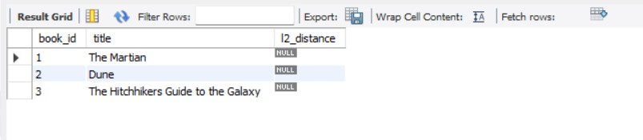
Cosine Similarity

Node.js API
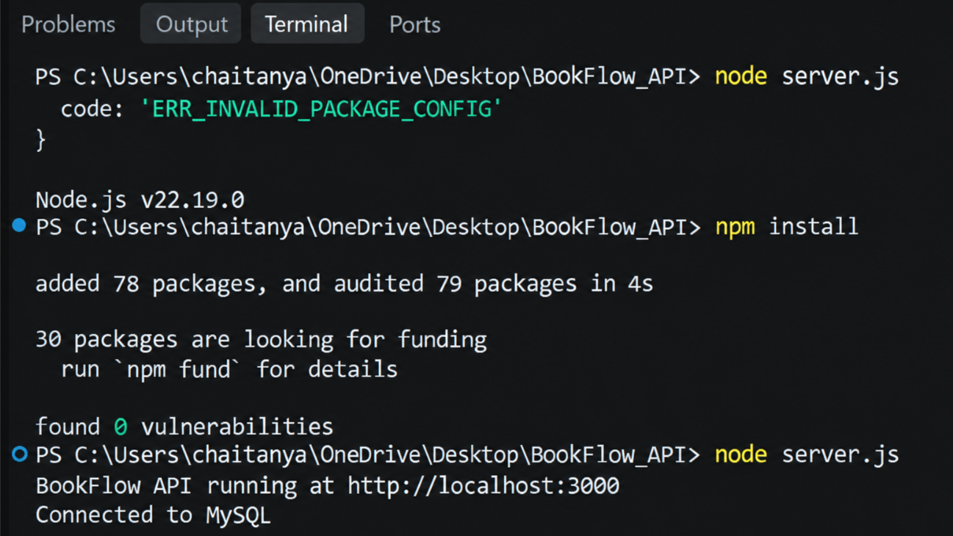
API running in browser
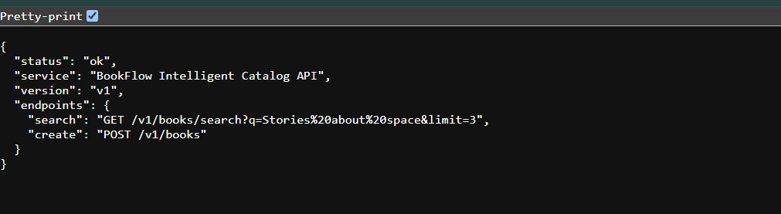
Swagger API documentation
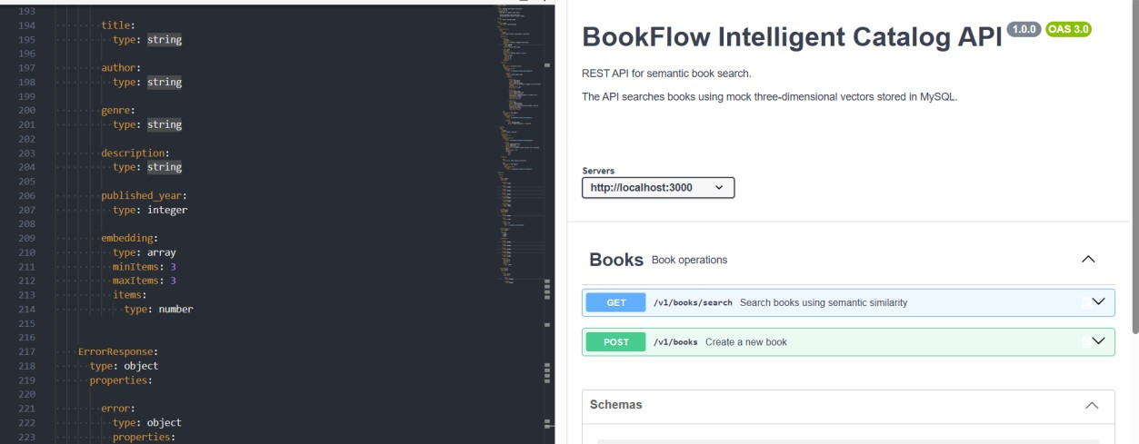
Semantic Search in Swagger
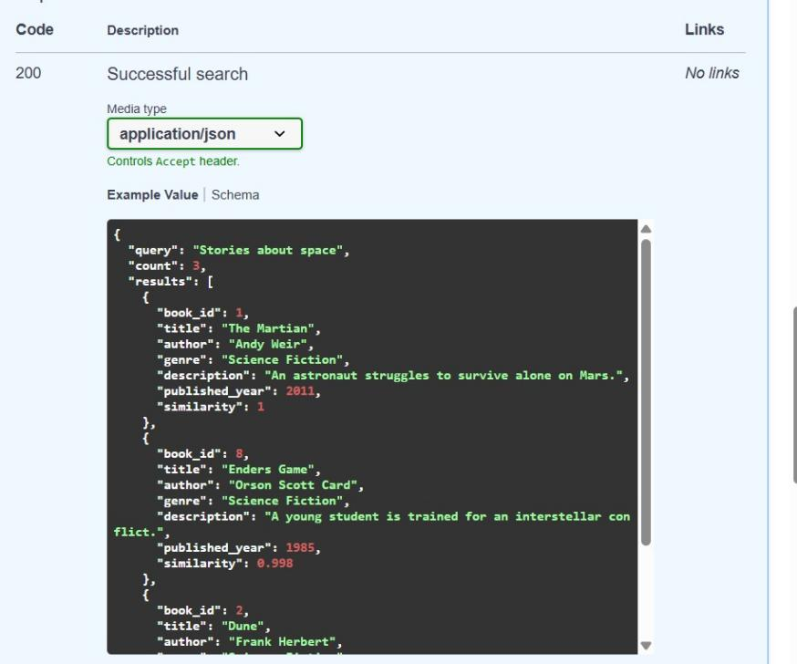
Missing q → 400 Bad Request
